**<TITLE>**

*<First Author Name>1,*

*Designation & Office name>*

*<Mail ID>*

*<Second Author Name>1,*

*Designation & Office name>*

*<Mail ID>*

**Abstract**

The intercontinental outbreak of the corona virus disease (COVID-19) is an apt reason of unexpected stress and adversity for many people.  Countries worldwide have adopted confining measures and called on their citizens to adopt physical distancing behaviours to contain the spread of the COVID‐19 pandemic. At a time when several countries are relaxing their lockdown measures, new uncertainties arise regarding the further evolution of a crisis becoming multifaceted, as well as the enduringness of public firmness to face and contain it. In this context, the sustained effectiveness of public health measures will depend more on the level of acceptance across populations. Citizens are called on to temporary sacrifice of daily freedom, while economic insecurity grows and social inequalities become more blatant the stress level increases. In this research paper we seek to develop a framework for analysing how the requirements of ‘physical distancing’ can be reconciled with the conditions that allow for the maintaining and strengthening of social cohesion, mutual solidarity, and a sense of collective efficaciousness , throughout the crisis. To study this we propose a summary of relevant findings and pragmatic policy derived from them.

## Keywords : COVID-19, Corona virus Pandemic, Stress vulnerability, Mental health, Resilience, Intervention strategies

**Period of study**:

The study was made towards the end of May 2020 – a time when millions had been diagnosed as infected by the corona virus and many hundreds of thousands had died of it across the world – most of the world population experienced weeks or months of life under curfew, lockdown, or similar stay‐at‐home orders.

**Introduction :**

News about the corona virus pandemic was alarming, with an overwhelming number of new cases and fatalities every day. Governments mandated hard measures of physical distancing, quarantine and lockdowns, and businesses were shut down, high lighting the impact and the inevitable long-term negative economic and health effects.The very horizons of citizens daily lives, their ability to travel and interact freely suddenly became limited. Anxiety and distress are normal responses to such extreme circumstances. Our stress systems have evolved to respond in highly adaptive ways, thereby enabling humans to deal with these challenges ([de Kloet et al., 2005](https://www.sciencedirect.com/science/article/pii/S0924977X20301322#bib0004)). While many are unsettled and concerned by the coronavirus pandemic, they all strive to adapt to this new reality. Not everyone can deal with stress and adapt easily to new circumstances. The current pandemic has affected everyone in some way or the other. Factors influencing individuals include living conditions, poverty, poor access to healthcare, illiteracy, uncertainty about the future (i.e. risk of unemployment), genetic background, previous life experiences and social support ([Southwick and Charney, 2012](https://www.sciencedirect.com/science/article/pii/S0924977X20301322#bib0011)). Thus, the impact of the current pandemic on incidence and severity of stress-related disorders will be highly heterogeneous.

## The Resilience Theory

People experience various kinds of adversity in life. There are personal experiences, such as illness, loss of a loved one, abuse, bullying, job loss, and financial instability. There is the shared reality of tragic events in the news, such as terrorist attacks, mass shootings, and natural disasters. People have to learn to cope with and work through very challenging life experiences. Resilience theory refers to the ideas of how people are affected by and adapt to things like adversity, change, loss, and risk.

Being resilient does not mean that people don’t experience stress, emotional upheaval, and suffering. Some people equate resilience with mental toughness, but demonstrating resilience includes working through emotional pain and suffering. Resilience is not a fixed attribute. Flexibility, adaptability, and perseverance can help people reproach into their resilience by changing certain thoughts and behaviors. Research shows that students who believe that both intellectual abilities and social attributes can be developed show a lower stress response to adversity and improved performance. Dr. Sood, who is a member of the Everyday Health Wellness Advisory Board, believes that resilience can be defined in terms of five principles:

1. Gratitude
2. Compassion
3. Acceptance
4. Meaning
5. Forgiveness

### ****Factors of Resilience****

Developing resilience is both complex and personal. It involves a combination of inner strengths and outer resources, and there is no universal formula for becoming more resilient. People are different in their characteristics: While one person might develop symptoms of depression or anxiety following a traumatic event, another person might not report any symptoms at all. A combination of factors contributes to building of resilience, and there isn’t a simple to-do list to work through adversity. In one longitudinal study, protective factors for adolescents at risk for depression, such as family cohesion, positive self-appraisals, and good interpersonal relations, were associated with resilient outcomes in young adulthood.

### ****Importance of Resilience****

Resilience is what gives people the emotional strength to cope with trauma, adversity, and hardship. Resilient people utilize their resources, strengths, and skills to overcome challenges and work through setbacks.People who lack resilience are more likely to feel overwhelmed or helpless, and rely on unhealthy coping strategies (such as avoidance, isolation, and self-medication). One study showed that patients who had attempted suicide had significantly lower resilience scale scores than patients who had never attempted suicide. Resilient people do experience stress, setbacks, and difficult emotions, but they tap into their strengths and seek help from support systems to overcome challenges and work through problems. Resilience empowers them to accept and adapt to a situation and move forward.

Resilience is “the core strength you use to lift the load of life,” says Sood.

**The 7 Cs of Resilience**

Pediatrician [Ken Ginsburg, MD](http://www.fosteringresilience.com/about.php), who specializes in adolescent medicine at the Children’s Hospital of Philadelphia, developed the 7 Cs model of resilience to help kids and teens build the skills to be happier and more resilient.

The 7 Cs model is centered around two key points:

1. Young people live up or down to the expectations that are set for them and need adults who love them unconditionally and hold them to high expectations.
2. How we model resilience for young people is far more important than what we say about it.

**The**[**American Academy of Pediatrics summarizes the 7 Cs**](https://www.aap.org/en-us/professional-resources/Reaching-Teens/Documents/Private/Building_7Cs_handout.pdf)**as follows:**

1. **Competence** This is the ability to know how to handle situations effectively. To build competence, individuals develop a set of skills to help them trust their judgments and make responsible choices.
2. **Confidence** Dr. Ginsburg says that true self-confidence is rooted in competence,Individuals gain confidence by demonstrating competence in real-life situations.
3. **Connection** Close ties to family, friends, and community provide a sense of security and belonging.
4. **Character**Individuals need a fundamental sense of right and wrong to make responsible choices, contribute to society, and experience self-worth.
5. **Contribution** Ginsburg says that having a sense of purpose is a powerful motivator. Contributing to one’s community reinforces positive reciprocal relationships.
6. **Coping** When people learn to ope with stress effectively, they are better prepared to handle adversity and setbacks.
7. **Control** Developing an understanding of internal control helps individuals act as problem-solvers instead of victims of circumstance. When individuals learn that they can control the outcomes of their decisions, they are more likely to view themselves as capable and confident.

The 7 Cs of resilience illustrate the interplay between personal strengths and outside resources, regardless of age.

**Suggestions**

Think of resilience as a seesaw or balance scale, where negative experiences tip the scale toward bad outcomes, and positive experiences tip it toward good outcomes. For some people during the COVID-19 outbreak, the resilience scale may look like this:

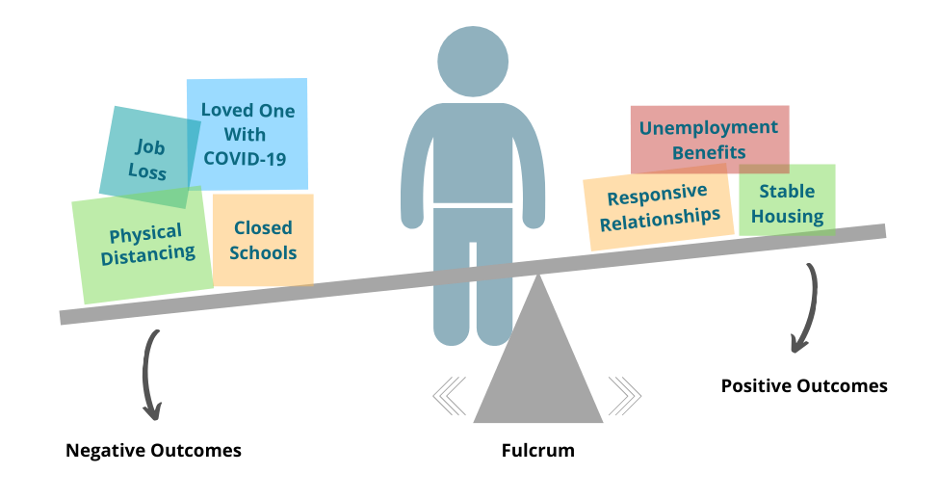

Source :Prime, H., Wade, M., & Browne, D. T. (2020). Risk and resilience in family well-being during the COVID-19 pandemic. *American Psychologist*.

The point where the scale balances is called the “fulcrum,” and if it is more to one side or the other, it can make it harder or easier to tip the resilience scale to the positive. Everyone’s fulcrum is in a different spot—which explains why each person is different in how easily we can counterbalance hardships in life. The good news is that the fulcrum can be moved by developing a toolkit of skills you can use to adapt and find solution

The science of child development points to **three ways** we can affect experiences and the balance of the resilience scale:

1. **Unload the Negative Side**

We can lighten the load on the negative side of the resilience scale by **reducing sources of stress** for families and program staff. Many organizations are already doing this and can draw on their experience to prepare for possible future periods of physical distancing and shutdown. Reducing sources of stress may include:

* Helping families **meet basic needs like food, shelter, diapers, health care, child care, and internet access** or connecting them with programs that can help.
* Guiding adults who are out of work through **applying for financial assistance.**
* Creating and providing children’s activity kits that include things like coloring books, crayons and markers, word searches, puzzles, books, craft supplies, etc. to **give parents and caregivers a break,**even for a few minutes at a time.
* **Encouraging parents, program staff, and co-workers to practice self-care—**even if it’s just taking a few minutes to themselves, going for a walk, or getting plenty of rest. Make sure staff are aware of and taking advantage of employee benefits such as employee assistance programs, mental health counseling, and paid time off.

## 2. Up Load the Positive Side

We can add to the positive side of the resilience scale by piling on positive experiences—especially through **responsive relationships**. The one thing that most children who develop resilience have in common is a stable, committed relationship with a supportive parent, caregiver, or other adult. Adults need those supportive relationships, too!

* If you work with families, you’ve likely already found new ways to check in with them while in-person visits aren’t possible—via phone calls or video chats, for example. The limitations of these alternatives may be a little frustrating, but **remember that you’re not just checking in; you’re also providing parents with time to engage in a responsive relationship** with a trusted adult during a time of physical isolation.
* **Maintain and encourage connections with family and friends.** Even though we’re all required to maintain physical distance, it’s important to call, video chat, email, or write letters to the people we care about to engage in responsive interactions, protect our emotional well-being, and manage the stress of living through this challenging time. (And, please access outside help and resources if you or someone else needs it.)
* Children’s development doesn’t pause during a crisis—and supporting that development and building resilience doesn’t have to take a lot of extra time or effort. **Back-and-forth “serve and return” interactions are simple and free, and you can do them during ordinary moments throughout the day.** If your baby makes a coo or gurgle during a diaper change, make a sound back. If your toddler points to something, point at it too and say what the object is. Playing with a child is a great way to engage in serve and return—and relieve some stress for all! (See this [how-to video](https://developingchild.harvard.edu/resources/how-to-5-steps-for-brain-building-serve-and-return/) and [step-by-step guide](https://developingchild.harvard.edu/resources/5-steps-for-brain-building-serve-and-return/) for more examples of serve and return.)

## 3. Move the Fulcrum

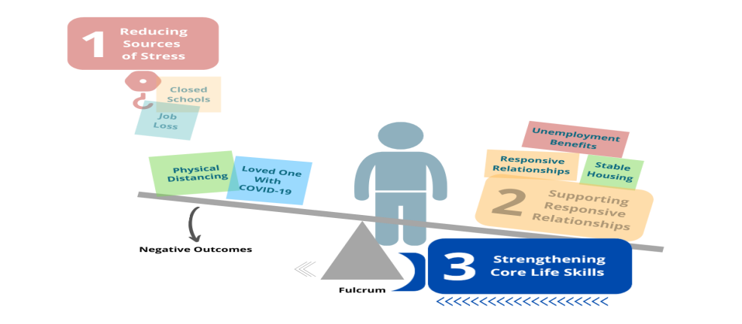

Source :Prime, H., Wade, M., & Browne, D. T. (2020). Risk and resilience in family well-being during the COVID-19 pandemic. *American Psychologist*.

We can make it easier for a scale to tip toward positive outcomes by **strengthening core life skills.**All of us need executive function and self-regulation skills to manage daily life, but stress makes it more difficult to use the skills we have. During the COVID-19 pandemic, we need these core life skills for things like planning less frequent trips to the grocery store or market, filling out forms for relief funds or loans, navigating support programs, and for managing work, home, and caring for children. Adults can strengthen these skills with small but helpful supports, like:

* Sending or signing up for text reminders of important appointments
* Using tools such as grocery list apps, menu planners, and daily schedules (and posting them for the whole family to see)
* Creating step-by-step checklists for accessing relief funds and filling out important applications

During a crisis like the COVID-19 outbreak, families need their immediate, basic needs met before they can focus on anything else. But, when the crisis is over, longer-term programs that support adults and children in building and practicing their core life skills will again be necessary and effective.

**Conclusion**

Many questions remain about how resilient we can be in the face of the corona virus pandemic. Even though there is no final answer, we anticipate that science will pro- vide guidance in a time where valid scientific information is sorely needed ( Holmes et al., 2020 ). Several initiatives have been initiated to gain more insight into the short and long-term psychosocial impact of the COVID-19 pandemic in the general population, patients with psychopathology and healthcare workers. It will be important to obtain data on the psycho-social impact in acute and recovered COVID-19 patients and their relatives on how to best mitigate the negative effects. Such studies will allow the identification of factors associated with resilience, ac- cording to living context, coping strategies, personal history and, if possible, biological features such as (epi)genetic background. This will provide a platform to develop community and personalized interventions to improve resilience and reduce the risk of psychopathology in the current and similar crises in the future stress challenges. In conclusion, we not only advocate for an increased focus on mental health during the corona virus pandemic, but we also highlight the urgent need of augmenting focus on resilience and on strategies to enhance it since resilience is pivotal to cope with the stress imposed by the virus out- break at the individual and societal level.

## References- *<All referencing style must cope with APA style>*

1. Centers for Disease Control and Prevention**Quarantine and isolation** <https://www.cdc.gov/quarantine/index.html> (2017) (accessed Jan 30, 2020). [Google Scholar](https://scholar.google.com/scholar_lookup?title=Quarantine%20and%20isolation&publication_year=2017&author=Centers%20for%20Disease%20Control%20and%20Prevention)
2. M-E Manuell, J Cukor**Mother Nature versus human nature: public compliance with evacuation and quarantine**Disasters, 35 (2011), pp. 417-442 [CrossRef](https://doi.org/10.1111/j.1467-7717.2010.01219.x)[View Record in Scopus](https://www.scopus.com/inward/record.url?eid=2-s2.0-79951624746&partnerID=10&rel=R3.0.0)[Google Scholar](https://scholar.google.com/scholar_lookup?title=Mother%20Nature%20versus%20human%20nature:%20public%20compliance%20with%20evacuation%20and%20quarantine&publication_year=2011&author=M-E%20Manuell&author=J%20Cukor)
3. K Newman**Shutt up: bubonic plague and quarantine in early modern England**

J Sol Hist, 45 (2012), pp. 809-834 [CrossRef](https://doi.org/10.1093/jsh/shr114)[View Record in Scopus](https://www.scopus.com/inward/record.url?eid=2-s2.0-84866911105&partnerID=10&rel=R3.0.0)[Google Scholar](https://scholar.google.com/scholar_lookup?title=Shutt%20up:%20bubonic%20plague%20and%20quarantine%20in%20early%20modern%20England&publication_year=2012&author=K%20Newman)

1. Public Health England **Novel coronavirus (2019-nCoV) – what you need to know**

<https://publichealthmatters.blog.gov.uk/2020/01/23/wuhan-novel-coronavirus-what-you-need-to-know/> (2020)(accessed Jan 31, 2020).[Google Scholar](https://scholar.google.com/scholar?q=Novel%20coronavirus%20%20%20what%20you%20need%20to%20know)

1. D Barbisch, KL Koenig, FY Shih**Is there a case for quarantine? Perspectives from SARS to Ebola** Disaster Med Public Health Prep, 9 (2015), pp. 547-553[CrossRef](https://doi.org/10.1017/dmp.2015.38)[View Record in Scopus](https://www.scopus.com/inward/record.url?eid=2-s2.0-84948436031&partnerID=10&rel=R3.0.0)[Google Scholar](https://scholar.google.com/scholar?q=Is%20there%20a%20case%20for%20quarantine%20Perspectives%20from%20SARS%20to%20Ebola)
2. SH Miles**Kaci Hickox: public health and the politics of fear** <http://www.bioethics.net/2014/11/kaci-hickox-public-health-and-the-politics-of-fear/> (2014)

(accessed Jan 31, 2020).[Google Scholar](https://scholar.google.com/scholar_lookup?title=Kaci%20Hickox:%20public%20health%20and%20the%20politics%20of%20fear&publication_year=2014&author=SH%20Miles)

**About the author-** *< Photo and brief profile description>*